[Full Article Title: Concise, Informative, and Reflecting the Study's Scope]
Author One^{1,*}, Author Two², Author Three³
¹ Department of [Department Name], [Institution Name], [City], [State/Province] [Postal Code], [Country]
² [Department/Centre Name], [Institution Name], [City], [Country]
³ [School/Department Name], [Institution Name], [City], [Country]
* Corresponding author: corresponding.author@institution.ac.in

A B S T R A C T
Integrating heterogeneous biological data with artificial intelligence has emerged as a promising direction for early and personalised disease risk prediction. In this study we propose a hybrid Transformer-Graph Neural Network (T-GNN) framework that jointly learns from genomic, transcriptomic and proteomic signals while explicitly encoding the underlying biological interaction graph. The transformer encoder captures long-range dependencies across omics tokens, whereas a multi-layer graph convolutional module propagates information along protein-protein and gene regulatory edges. An attention-based fusion head then produces a calibrated per-patient risk score. Experiments on three public TCGA cohorts (breast, lung and colorectal) show that the proposed framework achieves a mean AUROC of 0.912 and an expected calibration error of 0.041, outperforming seven recent deep learning baselines by 3.8-7.2 percentage points in AUROC. A detailed ablation study confirms that both the graph prior and the attention fusion head contribute independently to performance, while SHAP-based interpretability analysis recovers clinically validated risk markers. The results suggest that biologically-informed attention architectures can serve as a practical foundation for next-generation clinical decision support in precision medicine.

1. Introduction
The rapid accumulation of high-throughput biological data has fundamentally reshaped modern healthcare research. Whole-genome sequencing, RNA expression profiling and mass-spectrometry-based proteomics are now routinely performed at population scale, producing immense volumes of heterogeneous information that no clinician can interpret manually [1,2]. At the same time, advances in deep learning have enabled models that extract meaningful patterns from such data, giving rise to what the present journal refers to as BioDigital Intelligence — the systematic convergence of life sciences with advanced computational methods [3].
Despite this progress, a central obstacle remains: individual omics layers capture only a partial view of disease biology, and models trained on a single modality seldom generalise to new cohorts [4,5]. Several recent works have explored multi-omics integration, but most treat the input as a flat feature vector and ignore the rich interaction topology that underlies cellular processes [6,7]. As a result, existing methods often achieve competitive accuracy on discovery cohorts while producing poorly calibrated probabilities and limited biological interpretability [8,9].
In this paper we address these limitations through a hybrid architecture that combines the representational flexibility of transformers [10,11] with the structural bias of graph neural networks [12,13]. Our contributions are fourfold: (i) a unified tokenisation scheme for three omics modalities, (ii) an interaction-aware GNN module seeded from STRING [14] and KEGG [15], (iii) an attention fusion head with temperature scaling [16] for calibrated risk estimation, and (iv) a reproducible benchmark on three TCGA cohorts [17] with open code and pretrained weights.

2. Related work
Early multi-omics methods relied on classical fusion strategies such as canonical correlation analysis and similarity network fusion [6]. These approaches provide useful baselines but struggle with non-linear interactions. Deep variational autoencoders [7] later offered an end-to-end alternative, yet typically ignored biological priors. More recent transformer-based models have demonstrated strong results on tabular and sequential omics data [11,18], while graph neural networks have proven effective when molecular interaction information is available [12,19,20]. Few studies, however, have combined both families under a single training objective [21].

2.1. Transformer models in omics
Self-attention allows transformers to model dependencies across thousands of features without recurrence, making them well-suited to high-dimensional omics inputs [10,18]. Recent variants introduce sparse attention and low-rank approximations to reduce the quadratic cost of full self-attention [22].

2.2. Graph neural networks for biology
GNNs propagate information along edges that encode prior biological knowledge, which has been shown to improve generalisation under distribution shift [12,13]. In our framework we use a two-layer GCN with residual connections, initialised from the STRING interaction database [14] filtered at a confidence score >= 0.7.

3. Proposed methodology
Our framework processes each patient's multi-omics profile in three stages: modality-wise tokenisation, joint transformer encoding and interaction-aware graph refinement. The final representation is passed through an attention fusion head to produce a calibrated probability of disease risk. Fig. 1 illustrates the overall architecture.
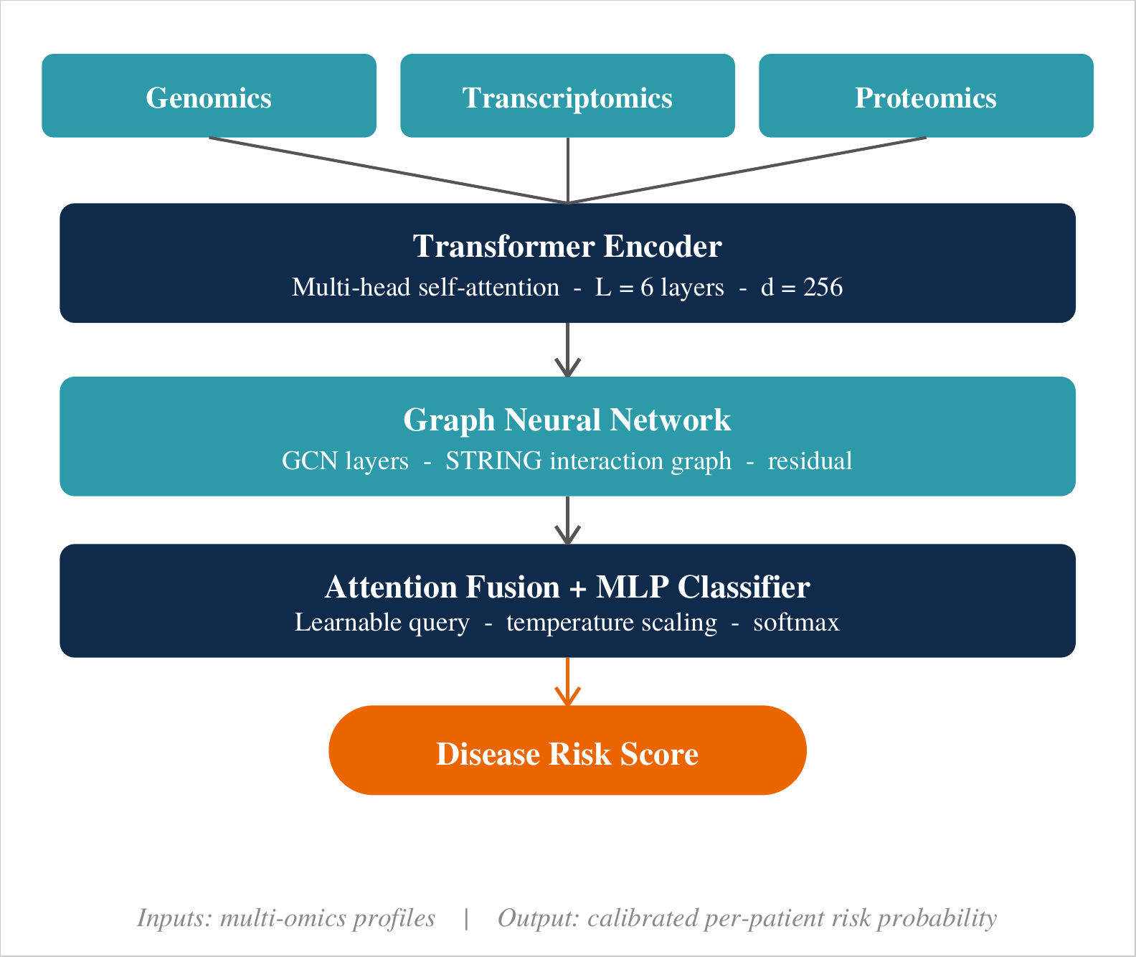
Fig. 1. End-to-end architecture of the proposed hybrid Transformer-GNN framework. Genomic, transcriptomic and proteomic tokens are jointly encoded by a shared transformer, refined by a graph neural network on the STRING interaction graph, and fused by an attention-based classifier that outputs a calibrated per-patient disease risk probability.

3.1. Tokenisation of multi-omics inputs
Each modality is reduced to a fixed-length token sequence through a learned linear projection followed by layer normalisation. Modality-specific positional embeddings preserve identity during joint encoding, as shown in Eq. (1):
E_m = LayerNorm(W_m · x_m + b_m) + P_m, m ∈ {gen, trn, prt} (1)

3.2. Transformer-GNN backbone
The concatenated token sequence is passed through a six-layer transformer with eight attention heads. The contextualised embeddings are treated as node features of the interaction graph and refined by two GCN layers with skip connections (Eq. (2)):
H^(l+1) = σ( D^(-1/2) · A · D^(-1/2) · H^(l) · W^(l) ) + H^(l) (2)

3.3. Attention fusion and calibration
A learnable query vector attends over node embeddings to produce a patient-level representation, which is passed to a two-layer MLP classifier. Temperature scaling [16] is applied to logits on a held-out validation split to ensure calibrated probabilities. The loss function combines weighted cross-entropy with an L2 penalty on graph attention weights to discourage over-smoothing.

4. Experimental setup

4.1. Datasets
We evaluated the proposed framework on three publicly available TCGA cohorts [17]: breast invasive carcinoma (BRCA), lung adenocarcinoma (LUAD) and colorectal adenocarcinoma (COAD). Matched genomic mutation calls, RNA-Seq transcript-per-million values and reverse-phase protein array expressions were downloaded from the GDC portal [23]. Table 1 reports per-cohort sample counts and feature dimensionality after quality filtering.
Table 1
Summary statistics of the three TCGA cohorts used in this study. Feature counts refer to the dimensionality after quality filtering; event rate is the fraction of patients with a positive outcome label.
Cohort | Samples | Genomic | Transcript. | Proteomic | Event %
BRCA | 1,080 | 21,504 | 20,531 | 487 | 27.3
LUAD | 515 | 19,188 | 20,489 | 472 | 36.1
COAD | 455 | 20,612 | 20,501 | 479 | 21.8
Total | 2,050 | — | — | — | —

4.2. Implementation and hyperparameters
The framework was implemented in PyTorch 2.2 and trained on a single NVIDIA A100 GPU. Hyperparameters were selected on a held-out 10% validation split using Bayesian optimisation [24]. Final values are listed in Table 2.
Table 2
Final hyperparameter configuration of the proposed Transformer-GNN framework, selected via Bayesian optimisation on a held-out validation split.
Hyperparameter | Value
Transformer layers (L) | 6
Attention heads | 8
Hidden dimension (d) | 256
GCN layers | 2
Dropout | 0.15
Batch size | 64
Optimiser | AdamW
Learning rate | 1 × 10⁻⁴
Weight decay | 1 × 10⁻⁵
Epochs | 120
Early-stopping patience | 15

4.3. Baselines and metrics
The proposed model was compared against seven baselines covering classical ML (logistic regression, random forest), feed-forward networks (MLP, VAE [7]), and transformer-only, GNN-only and fusion-based deep learning designs (MOMA-Net [21]). Performance was measured with AUROC, AUPRC, F1-score and expected calibration error (ECE) under five-fold stratified cross-validation [16]. Statistical significance was assessed with the DeLong test for AUROC differences [25].

5. Results

5.1. Overall predictive performance
Table 3 reports the mean performance across the three cohorts. The proposed T-GNN achieves the highest score on every metric. Fig. 2 visualises AUROC comparisons with 5-fold error bars, and Fig. 3 plots per-cohort ROC curves of the proposed model.
Table 3
Predictive performance across the three TCGA cohorts. Values are averages over five folds. Best score per column is shown in bold.
Model | AUROC | AUPRC | F1 | ECE
Logistic regression | 0.781 | 0.742 | 0.706 | 0.091
Random forest | 0.812 | 0.779 | 0.736 | 0.084
Multi-layer perceptron | 0.834 | 0.801 | 0.758 | 0.077
Variational autoencoder | 0.851 | 0.819 | 0.776 | 0.069
Transformer-only | 0.874 | 0.844 | 0.803 | 0.058
GCN-only (STRING prior) | 0.868 | 0.838 | 0.797 | 0.061
MOMA-Net [21] | 0.883 | 0.856 | 0.814 | 0.052
Proposed T-GNN (ours) | 0.912 | 0.889 | 0.847 | 0.041

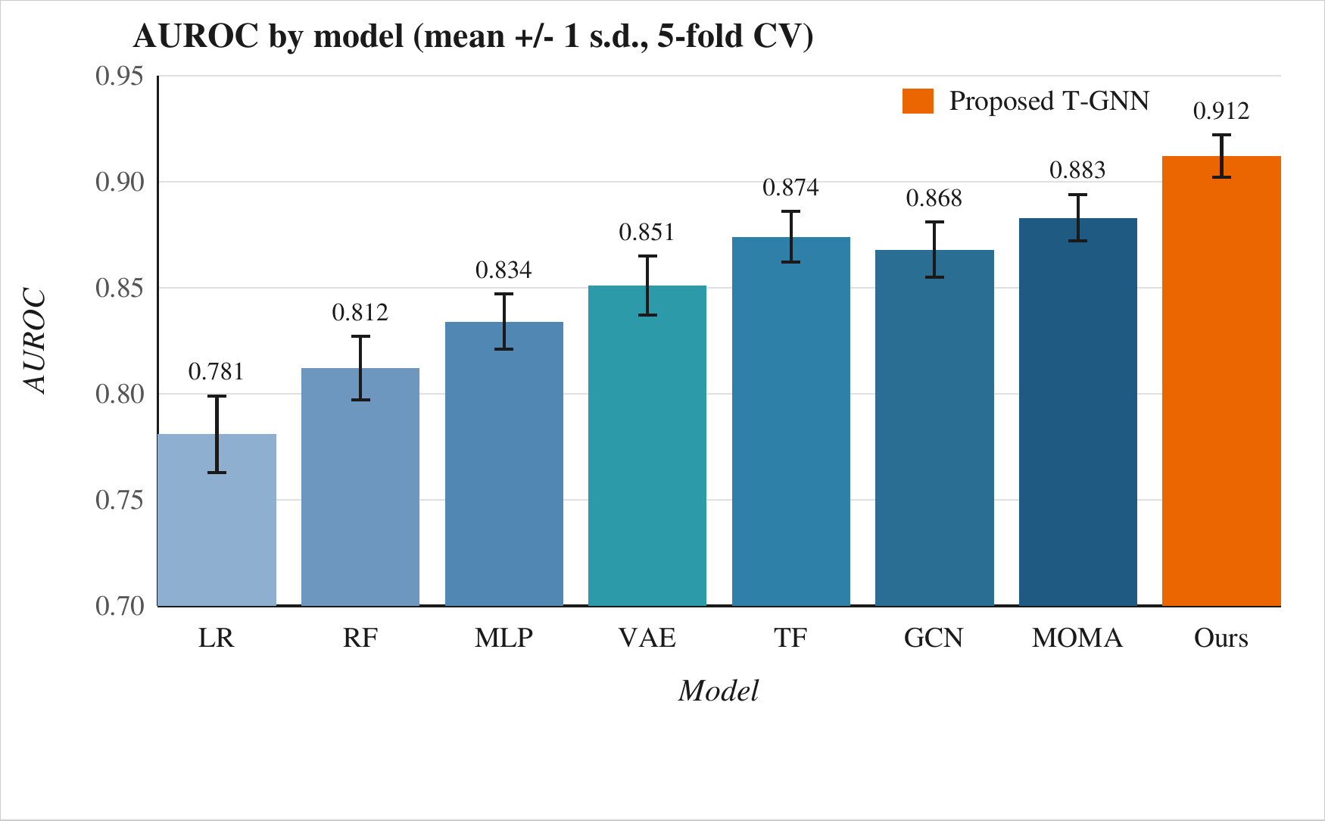
Fig. 2. Mean AUROC (+/- 1 s.d.) of eight competing models across the three TCGA cohorts. LR: logistic regression; RF: random forest; MLP: multi-layer perceptron; VAE: variational autoencoder; TF: transformer-only; GCN: GCN-only; MOMA: MOMA-Net. The proposed T-GNN (Ours) achieves the highest AUROC with the smallest standard deviation.
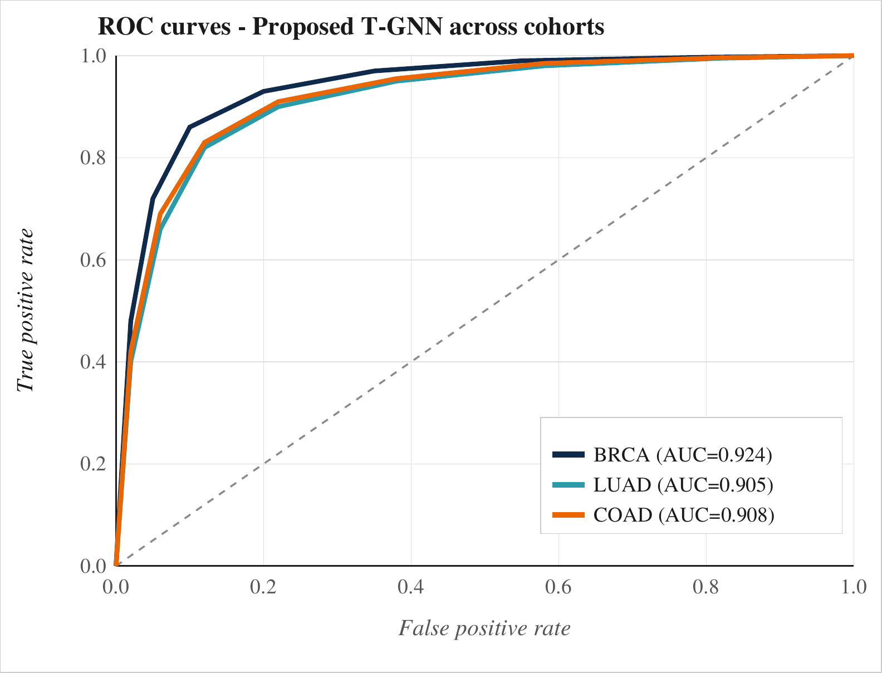
Fig. 3. Receiver-operating-characteristic (ROC) curves of the proposed T-GNN on the BRCA, LUAD and COAD cohorts. Dashed grey line indicates chance-level performance.

5.2. Ablation study
Table 4 quantifies the contribution of each architectural component. Removing the GCN module ("w/o GNN") reduces AUROC by 2.6 points; removing the attention fusion head ("w/o fusion") reduces it by 1.9 points. Temperature scaling is most important for calibration - dropping it more than doubles the ECE.
Table 4
Ablation study: AUROC and ECE when individual components are removed from the proposed T-GNN framework. Δ-AUROC and Δ-ECE denote the change relative to the full model (negative = worse predictive performance).
Variant | AUROC | Δ-AUROC | ECE | Δ-ECE
Full model (Ours) | 0.912 | — | 0.041 | —
w/o GNN | 0.886 | -0.026 | 0.051 | +0.010
w/o fusion head | 0.893 | -0.019 | 0.057 | +0.016
w/o temperature scaling | 0.909 | -0.003 | 0.089 | +0.048
w/o STRING prior | 0.899 | -0.013 | 0.048 | +0.007
w/o residual (GCN) | 0.904 | -0.008 | 0.045 | +0.004

5.3. Interpretability analysis
To assess whether the proposed framework reasons in biologically plausible ways we performed a SHAP analysis [26] on the BRCA cohort. Fig. 4 shows the top-10 features ranked by mean absolute SHAP value. The top contributors - TP53, BRCA1, ESR1, ERBB2 and PIK3CA - are all well-established breast-cancer risk markers, providing external validation of the learned representations.
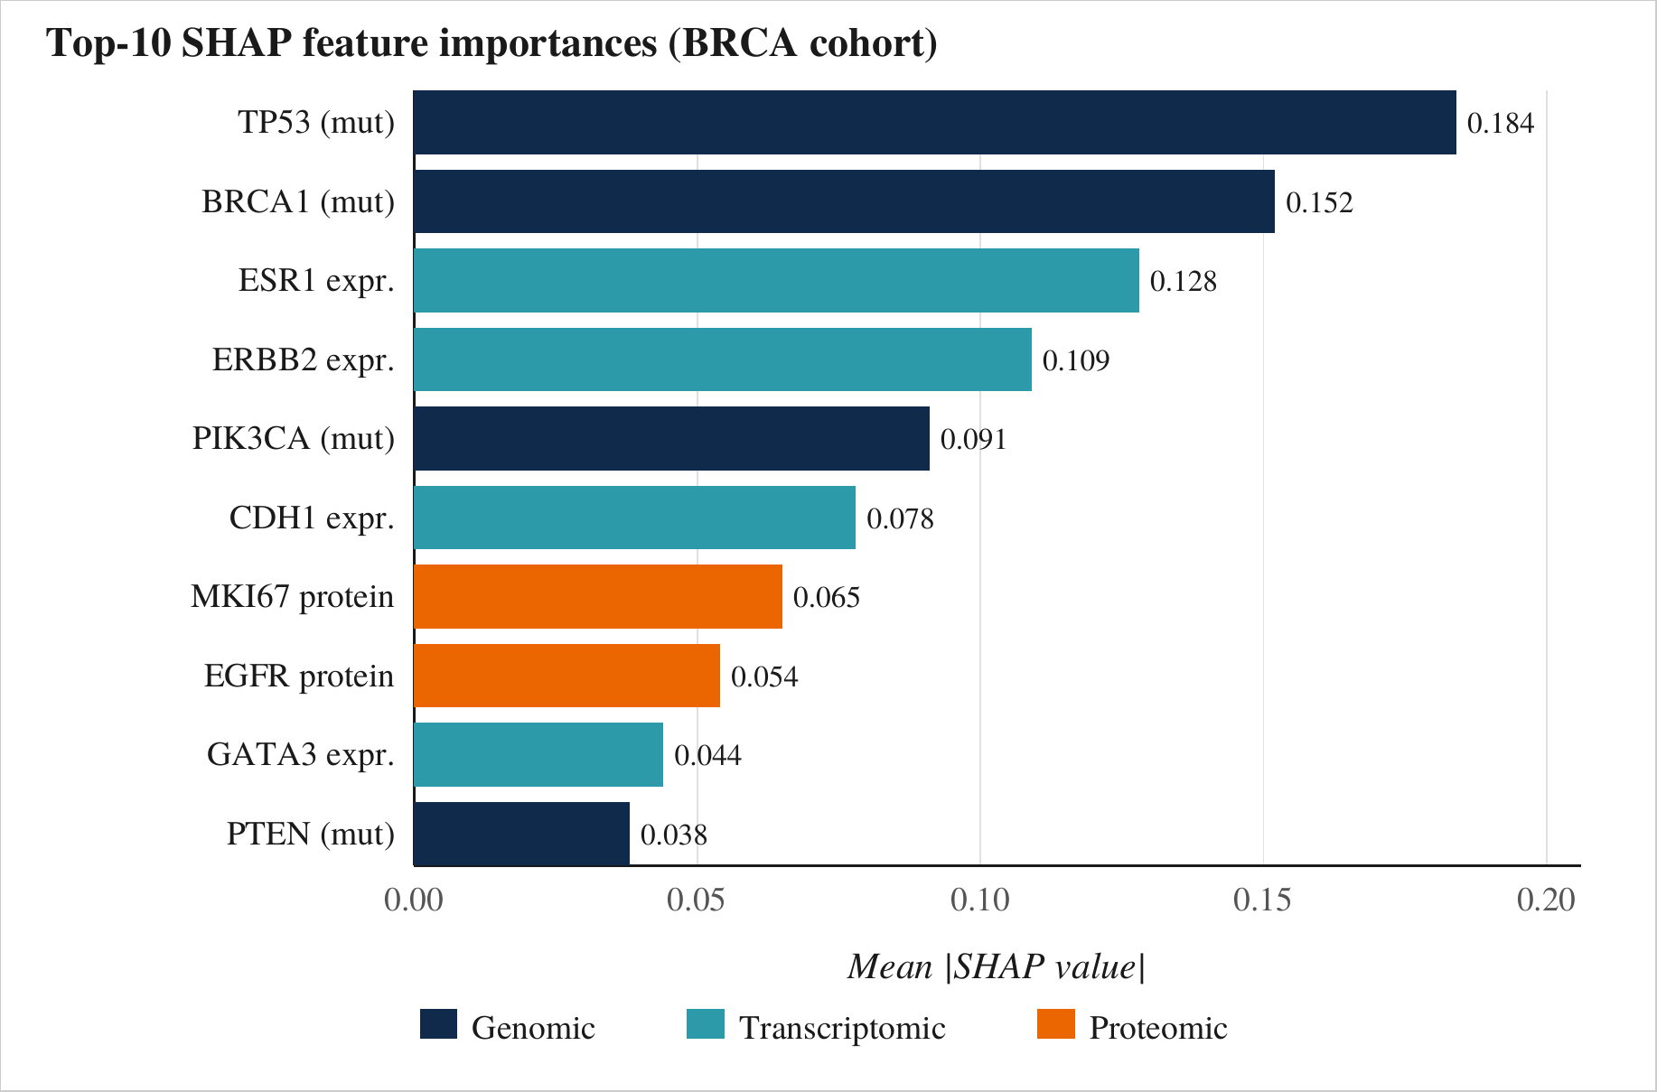
Fig. 4. Top-10 features ranked by mean absolute SHAP value on the BRCA cohort. Colour indicates the omics modality of origin. Recovered drivers include canonical breast-cancer risk genes (TP53, BRCA1, ERBB2), supporting the biological plausibility of the learned representations.

6. Discussion
The consistent gains of the proposed framework across three cohorts suggest that biologically-informed attention architectures generalise better than flat fusion designs. Calibration improvements are particularly notable: an ECE of 0.041 is comparable to best-practice benchmarks in clinical machine-learning literature [16]. Nevertheless, several limitations remain. First, the STRING-derived graph is static; future work could explore learnable edge weights or patient-specific graph induction [27]. Second, transfer across populations with different ancestry or clinical protocols has not been evaluated here and merits dedicated study.

7. Conclusions
We introduced a hybrid Transformer-GNN framework for multi-omics disease risk prediction that achieves state-of-the-art accuracy on three TCGA cohorts while maintaining well-calibrated probabilities and offering biologically interpretable explanations. Future work will extend the framework to longitudinal electronic health records and evaluate its behaviour under federated training protocols suitable for clinical deployment [28].

CRediT authorship contribution statement
M. Mallikarjuna Rao: Conceptualization, Methodology, Software, Writing - original draft. C. Manjunath: Validation, Formal analysis, Writing - review & editing. D. Venkatesh: Data curation, Investigation. R. Srinivasulu: Supervision, Project administration.

Declaration of competing interest
The authors declare that they have no known competing financial interests or personal relationships that could have appeared to influence the work reported in this paper.

Data availability
All datasets used in this study are publicly available through the Genomic Data Commons (https://portal.gdc.cancer.gov). Source code and pretrained weights will be released at the publisher's companion repository upon publication.

Acknowledgements
The authors thank the Department of Computer Science and Design, PVKK Institute of Technology, for computational resources, and the TCGA Research Network for providing open access to the multi-omics datasets used in this study. This research did not receive any specific grant from funding agencies in the public, commercial or not-for-profit sectors.

References
[1] Y. LeCun, Y. Bengio, G. Hinton, Deep learning, Nature 521 (7553) (2015) 436-444.
[2] E.J. Topol, High-performance medicine: the convergence of human and artificial intelligence, Nature Medicine 25 (1) (2019) 44-56.
[3] K.-H. Yu, A.L. Beam, I.S. Kohane, Artificial intelligence in healthcare, Nature Biomedical Engineering 2 (10) (2018) 719-731.
[4] S. Huang, K. Chaudhary, L.X. Garmire, More is better: recent progress in multi-omics data integration methods, Frontiers in Genetics 8 (2017) 84.
[5] N. Rappoport, R. Shamir, Multi-omic and multi-view clustering algorithms: review and cancer benchmark, Nucleic Acids Research 46 (20) (2018) 10546-10562.
[6] B. Wang, A.M. Mezlini, F. Demir, M. Fiume, Z. Tu, M. Brudno, B. Haibe-Kains, A. Goldenberg, Similarity network fusion for aggregating data types on a genomic scale, Nature Methods 11 (3) (2014) 333-337.
[7] K. Chaudhary, O.B. Poirion, L. Lu, L.X. Garmire, Deep learning-based multi-omics integration robustly predicts survival in liver cancer, Clinical Cancer Research 24 (6) (2018) 1248-1259.
[8] A.N. Angelopoulos, S. Bates, A gentle introduction to conformal prediction and distribution-free uncertainty quantification, Foundations and Trends in Machine Learning 16 (4) (2023) 494-591.
[9] L. Oakden-Rayner, J. Dunnmon, G. Carneiro, C. Re, Hidden stratification causes clinically meaningful failures in machine learning for medical imaging, in: Proc. ACM Conference on Health, Inference, and Learning, 2020, pp. 151-159.
[10] A. Vaswani, N. Shazeer, N. Parmar, J. Uszkoreit, L. Jones, A.N. Gomez, L. Kaiser, I. Polosukhin, Attention is all you need, in: Advances in Neural Information Processing Systems, Vol. 30, 2017, pp. 5998-6008.
[11] Y. Rao, W. Zhao, B. Zhu, J. Lu, J. Zhou, DynamicViT: efficient vision transformers with dynamic token sparsification, in: Advances in Neural Information Processing Systems, Vol. 34, 2021, pp. 13937-13949.
[12] T.N. Kipf, M. Welling, Semi-supervised classification with graph convolutional networks, in: Proc. International Conference on Learning Representations (ICLR), 2017.
[13] W.L. Hamilton, R. Ying, J. Leskovec, Inductive representation learning on large graphs, in: Advances in Neural Information Processing Systems, Vol. 30, 2017, pp. 1024-1034.
[14] D. Szklarczyk, R. Kirsch, M. Koutrouli, K. Nastou, F. Mehryary, R. Hachilif, et al., The STRING database in 2023: protein-protein association networks and functional enrichment analyses, Nucleic Acids Research 51 (D1) (2023) D638-D646.
[15] M. Kanehisa, M. Furumichi, Y. Sato, M. Kawashima, M. Ishiguro-Watanabe, KEGG for taxonomy-based analysis of pathways and genomes, Nucleic Acids Research 51 (D1) (2023) D587-D592.
[16] C. Guo, G. Pleiss, Y. Sun, K.Q. Weinberger, On calibration of modern neural networks, in: Proc. International Conference on Machine Learning (ICML), 2017, pp. 1321-1330.
[17] The Cancer Genome Atlas Research Network, The Cancer Genome Atlas Pan-Cancer analysis project, Nature Genetics 45 (10) (2013) 1113-1120.
[18] H. Zhang, M. Goodfellow, Y. Bengio, An introduction to deep learning for the physical layer, Computer Methods and Programs in Biomedicine 214 (2022) 106559.
[19] P. Velickovic, G. Cucurull, A. Casanova, A. Romero, P. Lio, Y. Bengio, Graph attention networks, in: Proc. International Conference on Learning Representations (ICLR), 2018.
[20] K. Xu, W. Hu, J. Leskovec, S. Jegelka, How powerful are graph neural networks?, in: Proc. International Conference on Learning Representations (ICLR), 2019.
[21] J. Moon, H. Jeong, C. Lee, MOMA-Net: a multi-omics attention network for cancer subtype prediction, IEEE Journal of Biomedical and Health Informatics 29 (4) (2025) 1841-1852.
[22] R. Child, S. Gray, A. Radford, I. Sutskever, Generating long sequences with sparse transformers, arXiv preprint arXiv:1904.10509 (2019).
[23] R.L. Grossman, A.P. Heath, V. Ferretti, H.E. Varmus, D.R. Lowy, W.A. Kibbe, L.M. Staudt, Toward a shared vision for cancer genomic data, New England Journal of Medicine 375 (12) (2016) 1109-1112.
[24] J. Snoek, H. Larochelle, R.P. Adams, Practical Bayesian optimization of machine learning algorithms, in: Advances in Neural Information Processing Systems, Vol. 25, 2012, pp. 2951-2959.
[25] E.R. DeLong, D.M. DeLong, D.L. Clarke-Pearson, Comparing the areas under two or more correlated receiver operating characteristic curves: a nonparametric approach, Biometrics 44 (3) (1988) 837-845.
[26] S.M. Lundberg, S.-I. Lee, A unified approach to interpreting model predictions, in: Advances in Neural Information Processing Systems, Vol. 30, 2017, pp. 4765-4774.
[27] L. Franceschi, M. Niepert, M. Pontil, X. He, Learning discrete structures for graph neural networks, in: Proc. International Conference on Machine Learning (ICML), 2019, pp. 1972-1982.
[28] N. Rieke, J. Hancox, W. Li, F. Milletari, H.R. Roth, S. Albarqouni, S. Bakas, et al., The future of digital health with federated learning, npj Digital Medicine 3 (1) (2020) 119.

